**Name: Mansoor Tariq**

**Roll no: 20l-1369.**

**Assignment # 3**

# **PART 1**

## **Brute force login attempt:**

When too many login attempts fail at once, brute force efforts are evident.

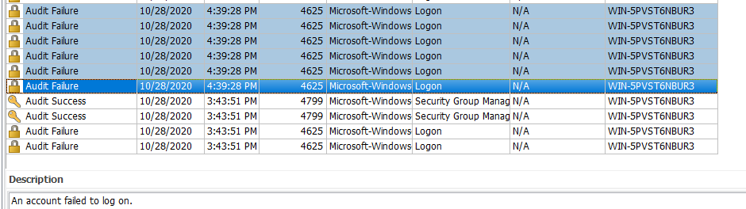

Figure 1

## **Account Targeted by attacked:**

Administrator account

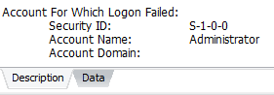

Figure 2

## **Time of attack:**

We can see the time of attack i.e. 4:39:28 PM in figure 1.

# **PART 2**

## **Plug in and remove USB device:**

A new device connected to the system is shown in the log file description.

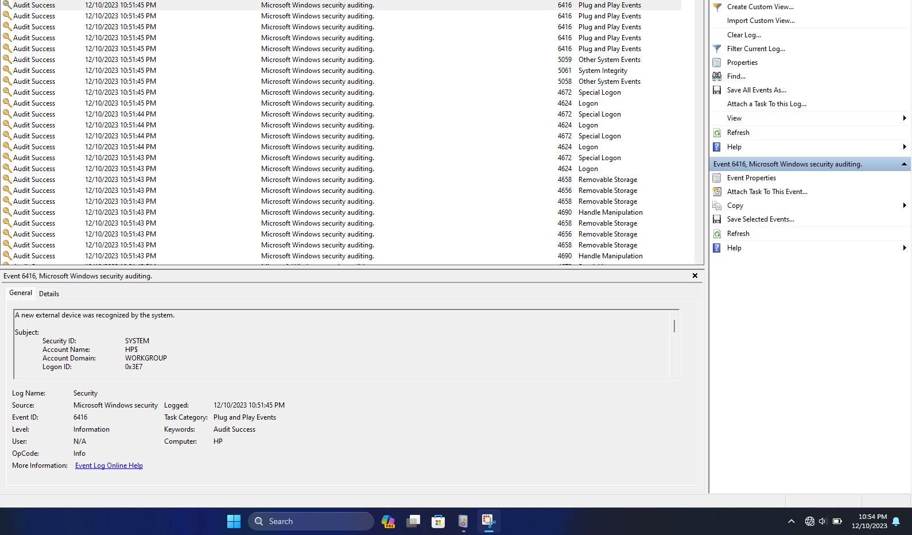

Figure 3

**Installing new program:**

Log file description reveals that the system has installed a new service.

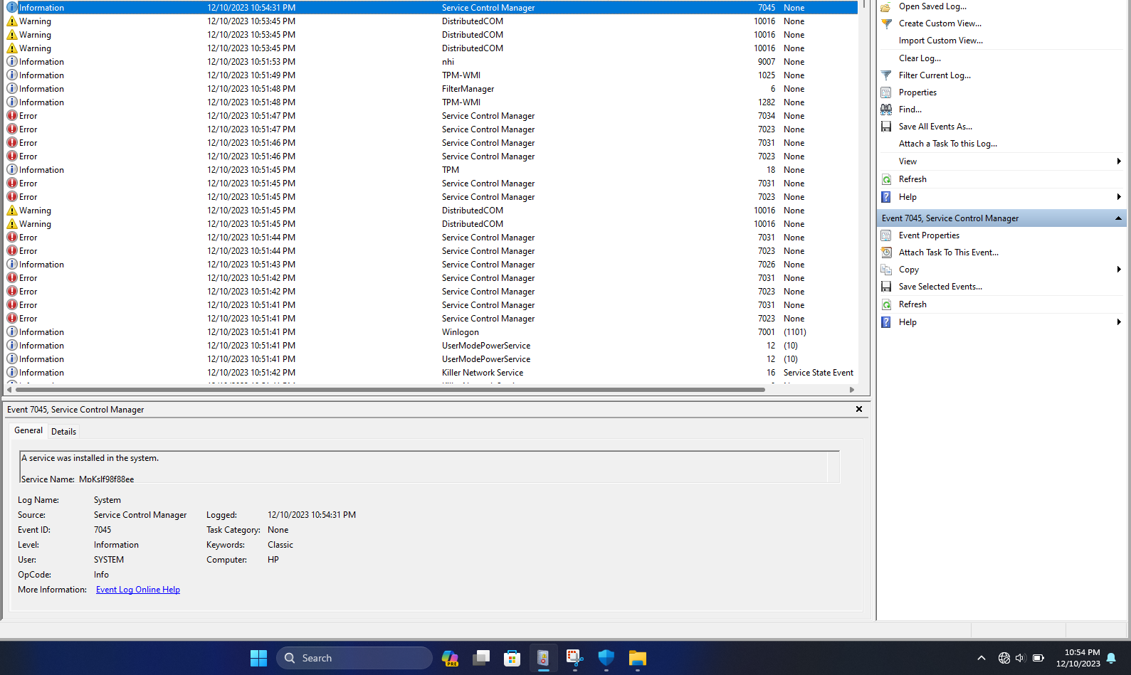

Figure 4

## **Disable User Account Control (UAC) notifications in Control Panel:**

## 

When user account control settings are altered, a new event is recorded in the user account management log file.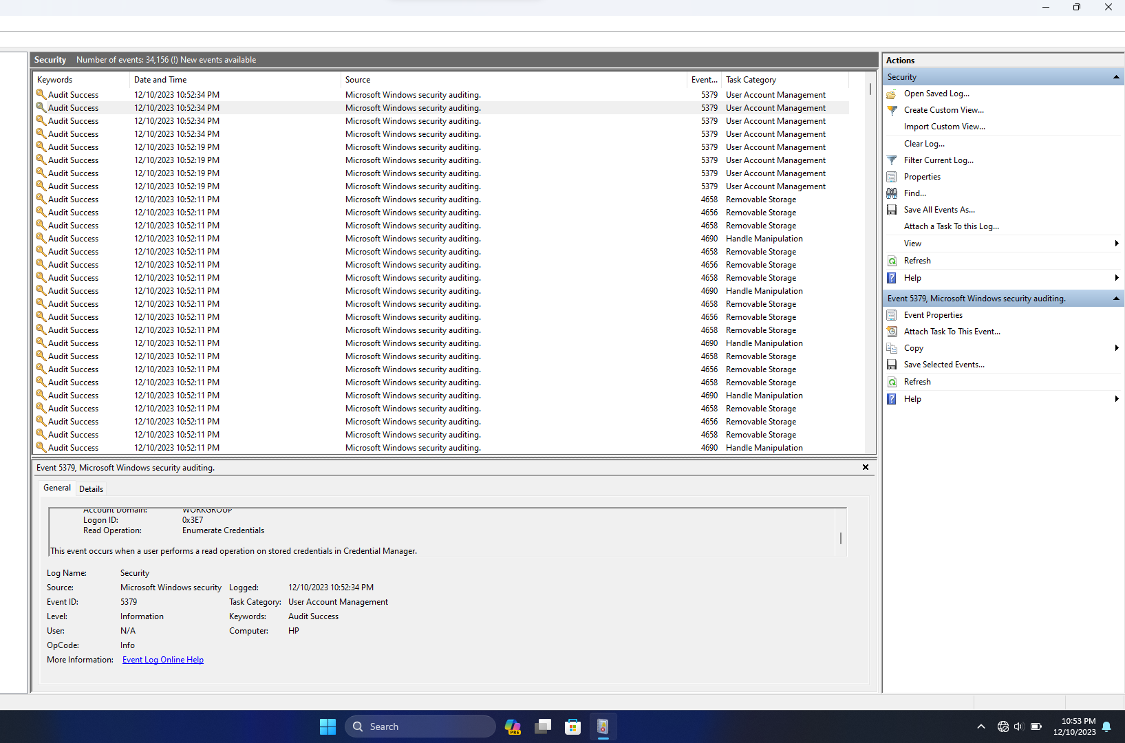

Figure 5

**Turn off real time virus protection in Windows Security settings:**

The log file indicates that Windows Defender has changed to a snoozed state.

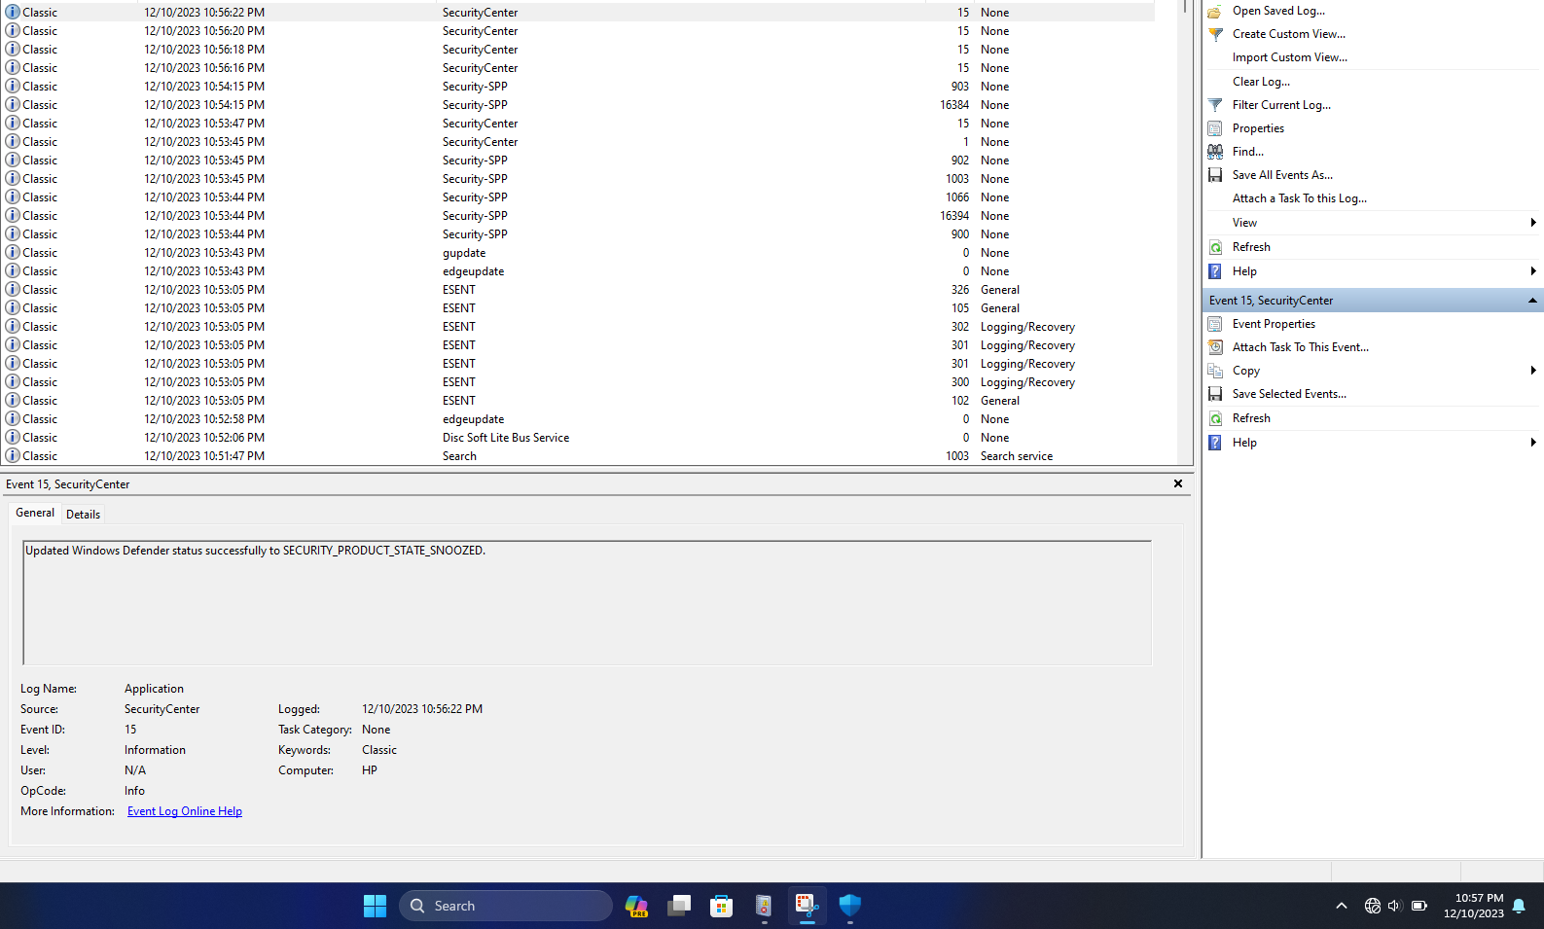

Figure 6